**CSE 370 – Database Systems**

## **Theory Section 15 / 16 | Assignment 02**

## **Spring 2023**

**Full Name (in Block Letter): __________________________________ ID: _____________________**

**Question 1 [CO1] : 20 Points**

Suppose that each of the following Update operations (a-j) is applied directly to the database state shown in Figure A2_1. **Consider each operation independent of each other. Each operation will be performed in the same state of Figure A2_1.** Discuss all integrity constraints violated by each operation (check Figure A2_2 for Referential integrity constraints on the database of Figure A2_1), if any, and the different ways of enforcing these constraints.

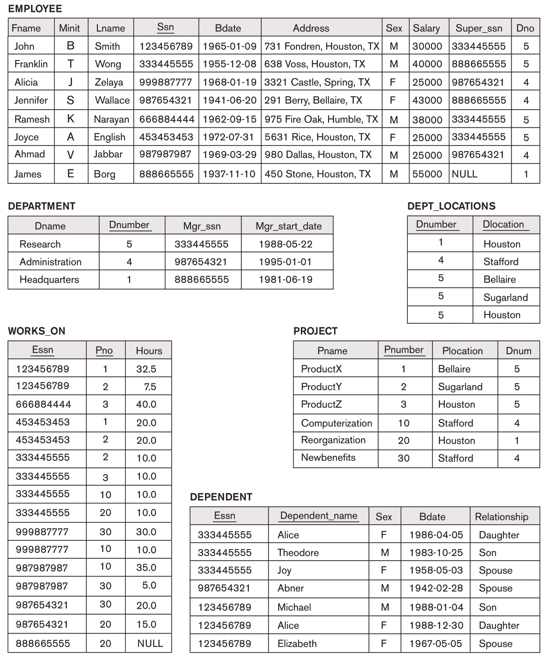

Figure A2_1 : COMPANY database.

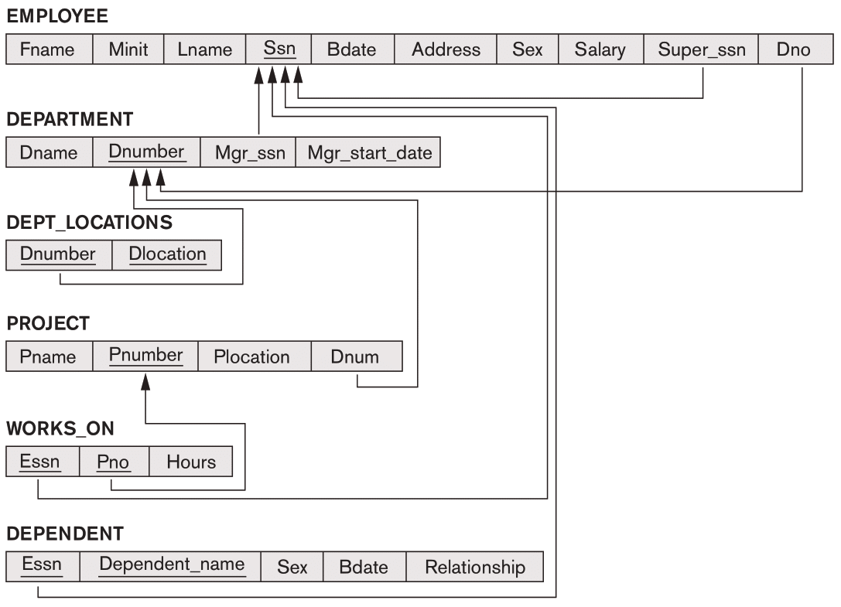

Figure A2_2 : Referential integrity constraints on the COMPANY database of Figure A2_1.

| **a.** Modify the HOURS attribute of the WORKS_ON tuple with ESSN= '999887777' and  PNO= 10 to '5.0'.  **Answer:** |
| --- |
| **b.** Insert <'ProductA', 4, 'Bellaire', 2> into PROJECT.  **Answer:** |
| **c.** Insert <'Production', 5, '987987989', '2007-10-01'> into DEPARTMENT.  **Answer:** |
| **d.** Insert <'677678989', NULL, '40.0'> into WORKS_ON.  **Answer:** |
| **e.** Insert <'453453453', 'John', 'M', '1990-12-12', 'Spouse'> into DEPENDENT.  **Answer:** |
| **f.** Delete the EMPLOYEE tuple with Ssn = '333445555'.  **Answer:** |
| **g.** Delete the WORKS_ON tuples with Essn = '333445555'.  **Answer:** |
| **h.** Modify the Super_ssn attribute of the EMPLOYEE tuple with Ssn = '999887777' to '987987988'.  **Answer:** |
| **i.** Delete the PROJECT tuple with Pname = 'ProductX'.  **Answer:** |
| **j.** Modify the Mgr_ssn and Mgr_start_date of the DEPARTMENT tuple with Dnumber = 5 to '123456789' and '2007-10-01', respectively.  **Answer:** |